Ideation Phase

**Brainstorm & Idea Prioritization Template**

|  |  |
| --- | --- |
| Date | 17 September 2022 |
| Team ID | PNT2022TMID40581 |
| Project Name | Classification of arrhythmia by using deep learning with 2-D ECG Spectral Image Repreasentation |

Step-1: Team Gathering, Collaboration and Select the Problem Statement

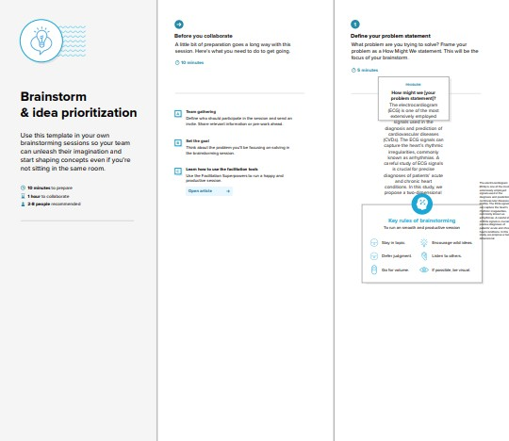

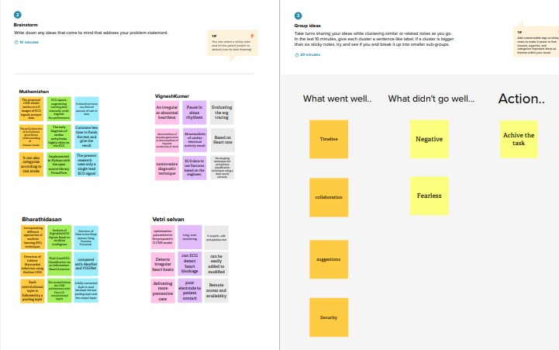Step-2: Brainstorm, Idea Listing and Grouping

Step-3: Idea Prioritization

